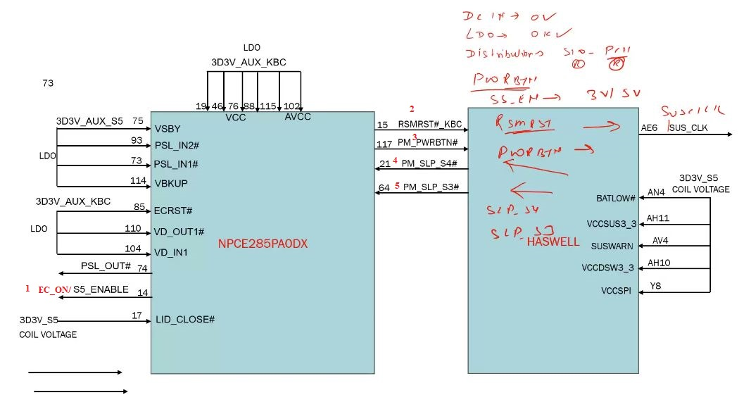

SIO Out Put Post Power Button Pressed
Note: Power Button Singnal First SIO ke Pass Jata hai…(sio ko pata chal jata hai button pressed hua hai).
- Button Press ke bad First Singnal SIO EC_ON# / S5_Enable#(if applicable) singnal 3/5 Buck Converter ko send krega to generte 3 & 5Volt supply.
- SIO Se Second Singnal RSMRST# (PCH Reset Signal Jese EC ka – ECRST#) Release hota hai, PCH ko.
RSMRST# ke bad PCH Active ho jayega aur First Signal Release karege SUS_CLK.
- Third Signal PM_PWRBTN# (Power Button Out) SIO Se Release hota hai PCH ko.
Note: jab SIO ON/OFF low hai to PM_PWRBTN# bhi low, jab ON/OFF par high to PM_PWRBTN# bhi high. SIO, PCH dono active ho gye
- Jese hi PCH PM_PWRBTN# ko high milega to PCH
PM_SLP_S4#
PM_SLP_S3#
Release kr ke SIO ko dega

